
Geo Location Based Product Price
Installation Guide

For any query or support write us care@technologymindz.com
www.technologymindz.com

- In the plugin package you will find below structure:
Technologymindz -> ProductFilter ->registration.php
->composer.json
->Block
->etc
->Helper
->view
- Copy and paste "Technologymindz" in your Magento 2x app/code directory. Clear cache and reindex.
Use command from magento root directory : php bin/magento setup:upgrade
To check module status : php bin/magento module:status
- Navigate to Store->Configuration, there you will find it "TM PRODUCT FILTER"
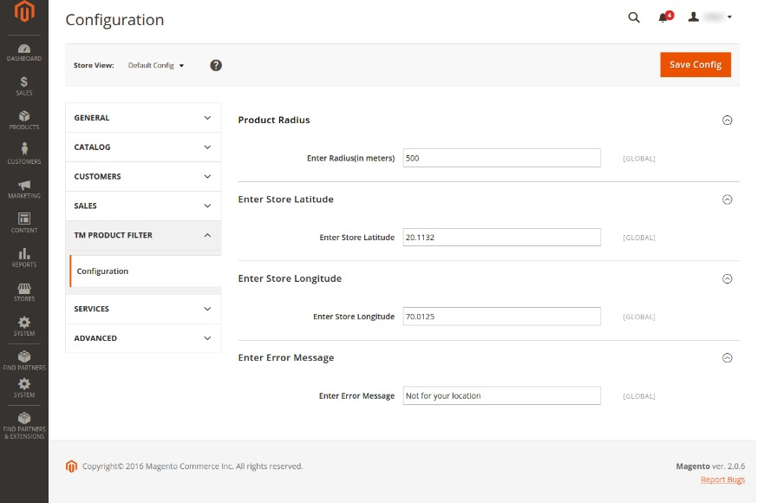
- You need to add simple four fields information there.
Product Radius : just put radius in meters from your store geo coordinate, it will allow add product in cart only within radius users.
Enter Store Latitude : Enter your Store Latitude (you can find it at http://www.latlong.net/)
Enter Store Longitude : Enter your Store Longitude (you can find it at http://www.latlong.net/)
Enter Error Message : Enter custom message to users outside your Radius.

- Your custom message will show to user outside radius.


