RESUME

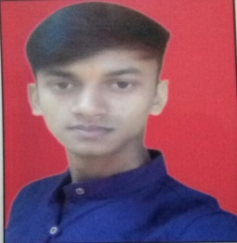

Sonu Kumar Shah
Sraja2405@gmail.com
PN. 8, Brijvatika, vatika, Jaipur,302022
+918290023008

Professional Objective

To work for and organization which provide me the opportunity to improve my skills and knowledge to growth along with the organization objective.

Education/Qualification/Academics
S No. | Standard | School/College | Board/University | Year | Percentage
1 | BCA | Poornima University, Jaipur | Poornima University | 2019 | 6.16 CGPA
2 | 12th | Shree Maheshwari Sr. Sec School | RBSE | 2016 | 62%
3 | 10th | Aadarsh Vidya Mandir Sr. Sec School | RBSE | 2014 | 55%

Technical Skills
- Knowledge about the Salesforce (Admin + Developer)
- Knowledge of Networking
- Basic knowledge of SQL Database
- Basic knowledge of Cloud computing on (Azure & AWS)
- Knowledge of java language.
- Knowledge about the LINUX (CentOS 7).

Projects
- College campus Network Designing.
- “Attendence Logger App” which is developed on SALESFORCE.
- Taken Exam of “STAR Exam of Air-Force” configured on Server using LINUX CentOS 7.

Hobbies
- Songs (listing and singing)
- Browsing on Net
- Drawing
Strengths
- Helping nature
- Discipline
- Honest
- Leadership
Weaknesses
- Shy nature
- fearful

Personal Profile

- Date of Birth : 05th May 1998
- Father’s Name :Manish Kr. Shah

Sonu Kumar Shah

