
Abhishek Sharma
Plot No. 65, Jai Bharat Nagar Near Sultan Nagar, Gurjar ki Thadi
Jaipur, Rajasthan
Pincode:-302019
Email:-abhigaur.sharma@gmail.com
Contact: +91-8696230568

Career objective
To enhance my professional skills, capabilities and knowledge in an organization which recognizes the value of hard work and trust me with responsibilities and challenges.

Education Qualification

Degree/standard | School/institute | University/board | Year of passing |  | Division  /%
Bachelor of technology (Computer Engineering) | Maharishi Arvind Institute of Engineering &Technology Jaipur | Rajasthan Technical University,Kota | 2018 |  | 60*
Senior secondary | Sand Dunes Academy, Jaipur | Board of Secondary Education, Rajasthan | 2014 | 51.80%
Secondary | Sand Dunes Academy, Jaipur | Board of secondary Education, Rajasthan | 2012 |  | 52%

Work Experience
Endive Software
Dec 2018 – September 2019
SEO Executive

Skills
- SEO
- SMO
- Google Analytics
- Research & Development
- SEMrush Tool
- Content Marketing

Achievements and credentials
- Participation in Theatre Play
- Won several awards in culture events at School&College
Strength
- Time management
- Passionate about computers
- Good Analytical & logical thinking
- Hardworking
- Result Driven
Personal details
Mother’s Name: Mrs.Santra Sharma
Father’s name: Mr. Kamla Shankar Sharma
Date of birth: 10-07-1997
Languages known: English, Hindi.
Hobbies: listening songs, watching movies etc.
I hereby declare that all the above said facts are true to the best of my knowledge and belief.

Place: Jaipur
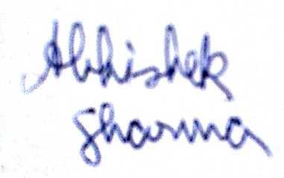
Abhishek Sharma

