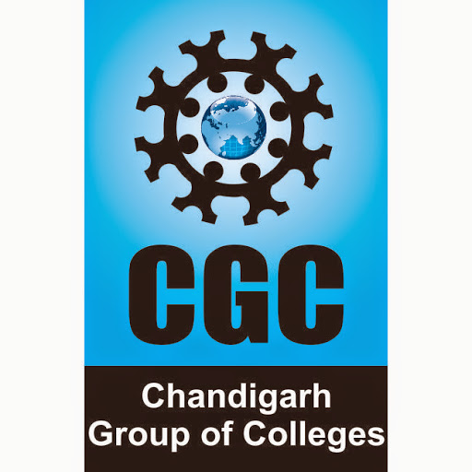
Mohit Kherwa

House number 86, Shiv Vihar Vistar, Manayawas
Mansarovar, Jaipur, Rajasthan
Contact: +91-75080 - 65465
E-mail: mohit.kherwa786@gmail.com

EDUCATIONAL QUALIFICATIONS

Year | Degree/Qualification | School/College | Board/University | %age
2018 | B.Tech (I.T) | Chandigarh Engineering College, Landran, Mohali. | Punjab Technical University | 69.15%
2014 | 10+2 | Navyug Sr. Sec. public School, Abohar. | PSEB | 56.4%
2011 | 10 | S.G.J. D.A.V Sr Sec Public School, Haripura. | PSEB | 70%

SOFTWARE/TECHNICAL COMPETENCIES

Operating Systems | : | Windows 7, Windows 8.1, Windows 10
Languages known | : | Basic C++
DBMS | : | MySQL

Experience:

6 months as an SEO executive.
Work description:
- Off page SEO Techniques like Social bookmarking, Blog commenting, Forum submission, Profile linking, Social media posting and Directory submission etc.
- Guest Posting for US projects on various niches like Health, Fashion, Home decor, Automobile, Tech and Pets etc
- Topic creation for the articles
- Relevant websites searches for posting articles
- Keyword Research
- Social Media Marketing
- Blog Posting
- Tools: Ahrefs.com, Moz.com, Majestic.com, Semrush.com, Seomatrickschecker.com, Coschedule.com, and Google keyword Planner etc.

PROJECTS UNDERTAKEN

Project Name: Handy Man services
Technology used | : | Android
Project Description | : | Handy man services provides the connection between common people and handy man like electrician, plumber and carpenter etc through a simple mobile application.
Team Size | : | 3

INTERPERSONAL SKILLS

- Flexible and Adaptable
- Leadership
- Calm and composed.
- Creative Thinking
- Hard working and responsible.

EXTRA-CURRICULAR ACTIVITIES

- Participated as a coordinator in National level information technology competition named “SMART INDIA HACKATHON, 2017”.
- Participated in march past in sports day at CGC, LANDRAN
- Participated in various LAN Gaming Contests
.

HOBBIES/INTERESTS
- Playing cricket
- Learning new technologies

DECLARATION
I do hereby declare that the above information is true to the best of my knowledge.

Mohit Kherwa

