Resume
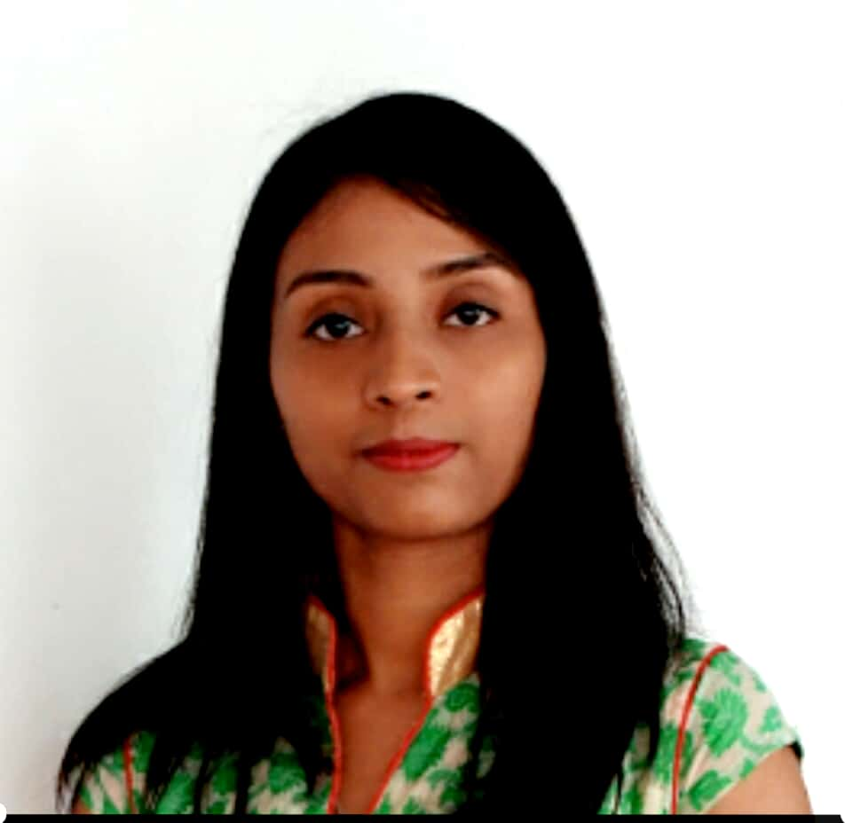

Name : Arupa Ghosal
Address : D/o Ashutosh Ghosal, South JKD Colliery
PS- South JKD, Distt.- Korea, Chhattisgarh, 497448
Mobile No : +919407743659
E-mail : arupaghosal33@gmail.com

Objective:
Success and failure both are part of life. To pursue a professional career, where my skills and creativity can be utilized in maximizing company profits while providing career advancement opportunities

Academic Qualifications:

Degree / Certificate | Qualification | Institute | Board /  University | Year | Aggregate % / CGPA
Bachelor  Degree | B. Tech in  Electronics & Communication | University of Engineering & Management,  Jaipur | UGC | 2016-2020 | 6.76
12th | Higher Secondary | Sri Chaitanya Educational Institute | CBSE | 2016 | 76.4
10th | Secondary | Kendriya  Vidyalaya  JKD | CBSE | 2014 | 8.2

Subjects of Interest:
- Signal System
- Analog Communication

Skills and Expertise:

- Programming in C, C++

Additional Courses:
- NPTEL ( National Program on Technology Enhanced Learning )
  - Principles of Signals and system
  - Soft Skills
  - Technical English for Engineers
  - Better Spoken English

Training:

Training Title: Android studio-3(Eclipse app), JAVA Web Developer.
June 2018
Training Description: This training is based on creation of applications that can be operated through any android device. In this I have created a shopping application, where user can select their gender and other preferences accordingly they will be provided with the products.

Project Title: IOT based Indoor Guide and Tracking System
Project Description: This project is completely based on IoT, it will work for indoor positioning and tracking of person or an object.

Achievements:

- Coordinator in event of IETE 2019 organized by UEM, Jaipur during February 2019
- Submitted a project on Traffic signaling using 555 timer under IETE 2019 organized by UEM, Jaipur during February 2019
- Secured 2nd-position in Techno-Cultural Fest 2018 in sports events at UEM, Jaipur during September 2018
- Coordinator in Robotics event of Techno- Cultural Fest 2018 at UEM, Jaipur during September 2018
- Top 3 in Aptitude Exam- 2017 organized by UEM, Jaipur
- Won many prize for running and sports events in school level and inter-school competitions in the year 2006-2014, Kendriya Vidayalaya JKD

Hobbies:
- Playing badminton
- Listening music

Family Details:

Details | Name | Occupation
Father | Ashutosh Ghosal | Surveyor, SECL
Mother | Rupali Ghosal | Family Manager

Personal Details:

Date of Birth : 29th October, 1998
Gender : Female
Languages Known : English, Hindi and Bengali
Nationality : Indian
Country of Residence : India

Declaration:

I hereby declare that the information furnished above is true to the best of my knowledge.

Date: 02/09/19 Arupa Ghosal

