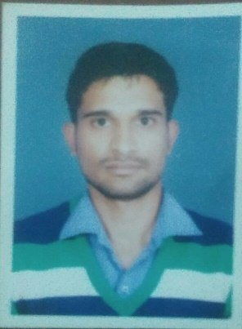
Manoj Jangir
Phone: (+91) 9782882389
E-mail: manojjangir233@hotmail.com
Address: G 191 A, Bhawani nager , Murlipura, Jaipur-302039 (Raj.)

I intend to establish myself as Web Developer , contributing to the company's growth
and in turn ensuring personal growth with in the organization. I believe that my technical,
functional and communication skills will enable me in facing the challenging career
ahead.

Professional Experience

Organization | Duration | Designation | About Company
- Next Big Technology  jaipur | sep 2015 to sep  (2 years) | Web Developer  (Wordpress developer) | Developed and implemented Online web Services and Mantinance  https://nextbigtechnology.com/

Academic Qualification

Qualification | Board/University | Year of Passing
B.Tech | Rajasthan technical university | 2013
12th | Rajasthan Education Board | 2008
10th | Rajasthan Education Board | 2006

Project Undertaken during current job :
https://rojgarfamily.com/izlebeni
http://www.3-keys.com/
https://www.pillrite.com/

Computer Skills
- Coding / Scripting :- php, wordpress , HTML
- Database :- MYSQL
- Operating System :- Linux, CentOS, Windows
- Tools :- Netbeans, Eclipse ,subline, notpad++

Hobbies | Strengths | Personal
- Yoga  - Traveling  - Listening Music | - Having strong desire to learn and passionate to my work.  - Self motivated person. | - DOB: 21th nov, 1989  - Marital Status: Unmarried  - Languages: Hindi, English

