Resume | 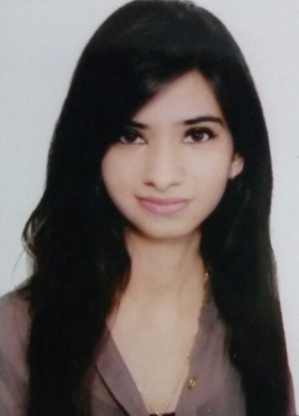
Personal information
Surname/First Name | BHATI,DRISHTI
 | 2-A-37 JAWAHAR NAGAR  sriganganagar  India , 335001
 | Fixed: +91 7823877173 |  |  |  |  |  |  |  |  | Work: +91 8209073833  Personal: +91 9413820304
 | drishtibhati786@gmail.com
Nationality | Indian
Date of birth | 08/10/1996
Gender | Female
 | https://www.linkedin.com/in/drishti-bhati-34ab58170
Education | Graduation
Dates | From 2016 to 2020
Title of Qualification awarded | bachelors of technology
Principal subjects/occupational skills covered | Computer science of technology
Name and type of organisation providing education and training | Rajasthan University of technology,kota,India
Projects
Dates | From October 2016 to October 2016
Project #1
Principal Subjects | College Management system
Programming language | JavaScript
Project #2
Principal Subjects | Online hotel booking
Programming language | Web Development
Project #3
Principal Subjects | Snake Game
Programming language | C language
Project #4
Principal Subjects  Programming language | Tic-Tac-Toe  C++
Internship detail
Company Name | TCS (tata consultancy services)
Project name | TCS_BaNCS_SP
Position | Java developer
duration | 27-march,2019 to 27-july,2019
Place | Tata consultancy services , seepzsez andheri  ODC 3 , INTERSIL BUILDING  ANDHERI EAST  MUMBAI , Maharashtra 400096
Mentor name | MR. VIVEK JOSHI (project leader)
 | Hindi
  Additional Information
  Mother tongue(s) | Hindi
Other language(s)
Self-assessment |  | Understanding |  |  |  |  | Speaking |  |  |  |  | Writing
European level (*) |  | Listening |  | Reading |  |  | Spoken interaction |  | Spoken production
English |  | C2 | Proficient | C2 | Proficient |  | C2 | Proficient | C2 |  | Proficient | C2 | Proficient
Hindi |  | B2 | Independent | B2 | Independent |  | B2 | Independent | B2 |  | Independent | B2 | Independent
 | (*) Common European Framework of Reference for Languages
Driving licence | Yes, Category B
References | Available upon request

