BHUMIKA MATHUR
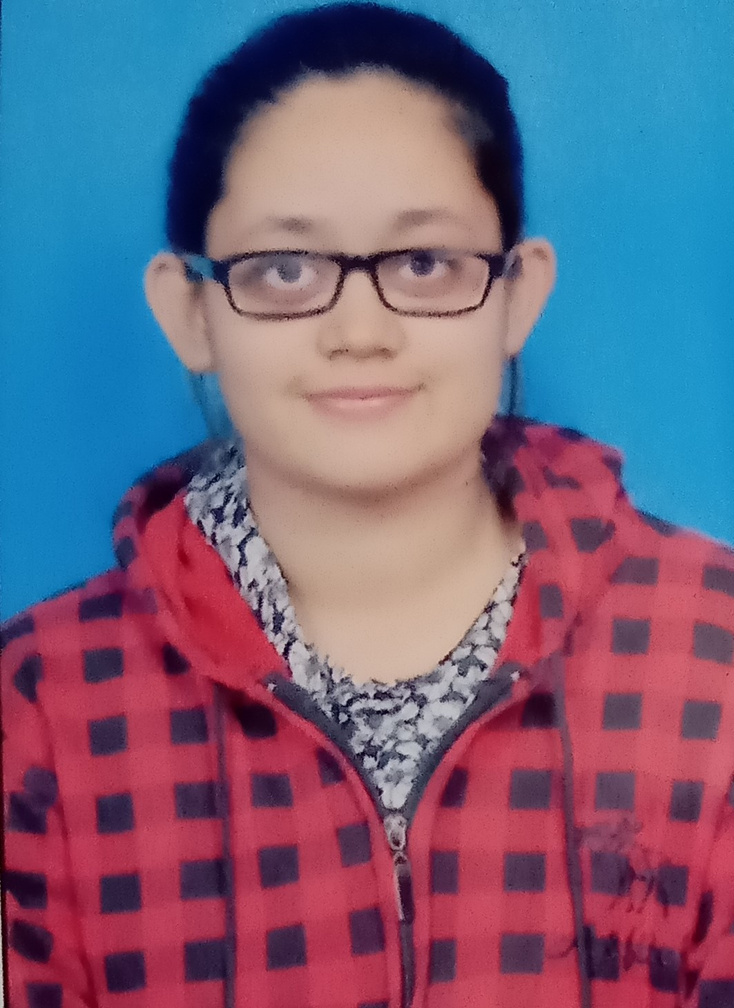

CAREER OBJECTIVE
To gain employment with a company or institution that offers me a constantly positive
atmosphere to learn new technologies & implement them for the betterment of the
business.
EDUCATIONAL QUALIFICATIONS
 | Masters of Business Administration (MBA- HR & Marketing)  (Biyani Institute of Science & Management) | 2018- Till now
 | Bachelors of Business Administration (BBA)  (Biyani Girls Colleges) | 2015-2018
 | Senior Secondary Education  (Motherland Public School) | 2015
 | Secondary Education  (Motherland Public School) | 2013

INTERNSHIPS
- Internship in Reliance Retail Industries Ltd. for 2months (Anand Bhawan, Jaipur).
- Internship at Birla Auditorium in the event Jaipur Health Festival.
- Training as lead volunteer in JECC India Industrial Fair-2018 (Sitapura, Jaipur).
- Internship in TDI MAD Alibaba.com (C-Scheme, Jaipur).
ACHIEVEMENTS
- Leader of Media Bites group during the internship at Birla Auditorium.
- Lead volunteer from Biyani Girls College at Indian Industrial Fair -2018.
- Anchoring in Biyani Group of Colleges & at TDI MAD Alibaba.com event.
- Participated two times in a row in blood donation camp organised by Rotary Club at Biyani Girls College.
- Won first prize at PowerPoint presentation held in Biyani Girls College on topic “Library Cum Cafeteria”.
- Coordinator of NSS.
- Head girl in Motherland Public School.
- Achieved 100% attendance award in Adarsh Public School.

TECHNICAL SKILLS
- Microsoft Office Specialist(MOS) along with C++
- RSCIT Course

CONFERENCES & SEMINARS ATTENDED
- Global Village event held in Poornima University in 2018.
- Breast Cancer Awareness seminar.
- JECC Indian Industrial Fair-2018.
- 10th , 12th, 13th & 14th International BICON seminars.
- NSS 7 days camp & seminar.
- Participated in Jaipuriya International Quiz Competition.
- Movie promotional events held in Biyani Group of Colleges & many more.
HOBBIES & INTEREST
- Listening Music
- Reading Novels
PERSONAL INFORMATION
NAME : BHUMIKA MATHUR
FATHER’S NAME : Mr. DINESH KUMAR MATHUR
DATE OF BIRTH : 08/01/1997
MOBILE NO. : 8005900268
Email I’d : bhumdirama@gmail.com
ADDRESS : F-3, SHIVAM RESIDENCY –I, PLOT NO. 34-35, K G N BAGH, SHIV. NAGAR, NIWARU ROAD, JHOTWARA, JAIPUR
DECLARATION
All the information presented in this CV/ Resume is true.
DATE : SIGN :
PLACE:

